**Make sure your project is already submitted to GitHub with all the necessary files required.**

Config file required for Heroku:

**Procfile:** It has the information that Heroku needs so as to which file should be executed first.

**requirements.txt**: It has the information of all the libraries that are required for my environment when the application is deployed in Heroku.

Logged into Heroku:

Gave a name for the app and clicked on Create app.

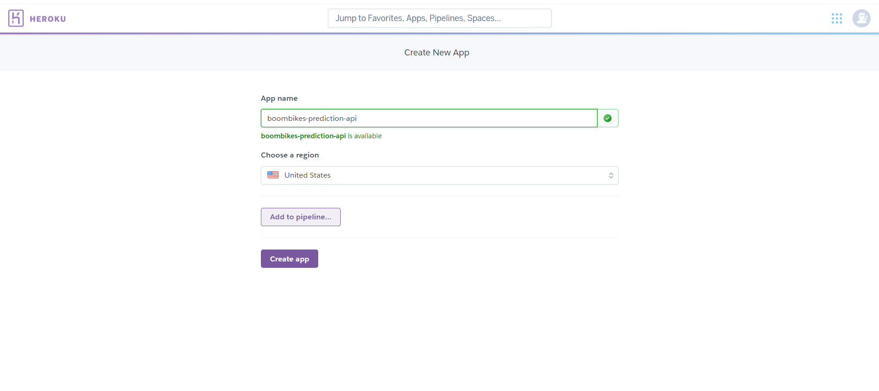

On the Heroku dashboard, clicked on deploy. Here clicked on GitHub for connection:

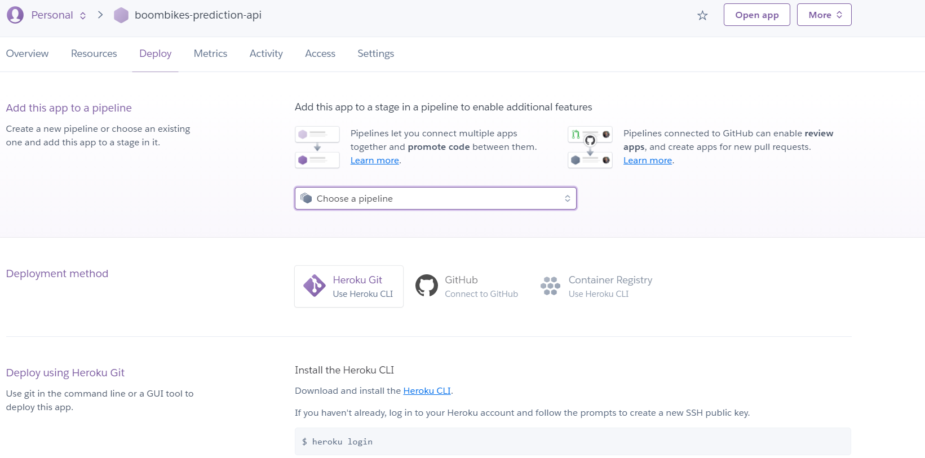

Clicked on Authorize Heroku: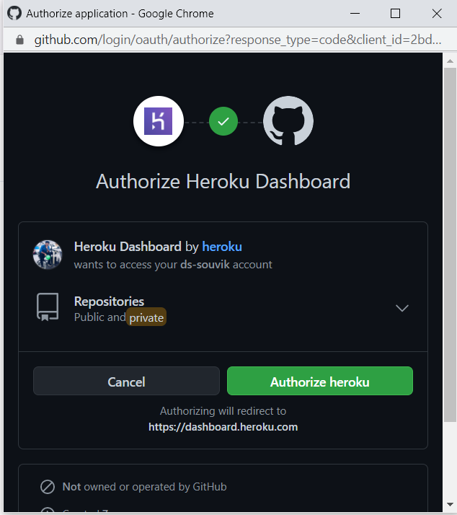

Selected the project repository from my profile and clicked on search:

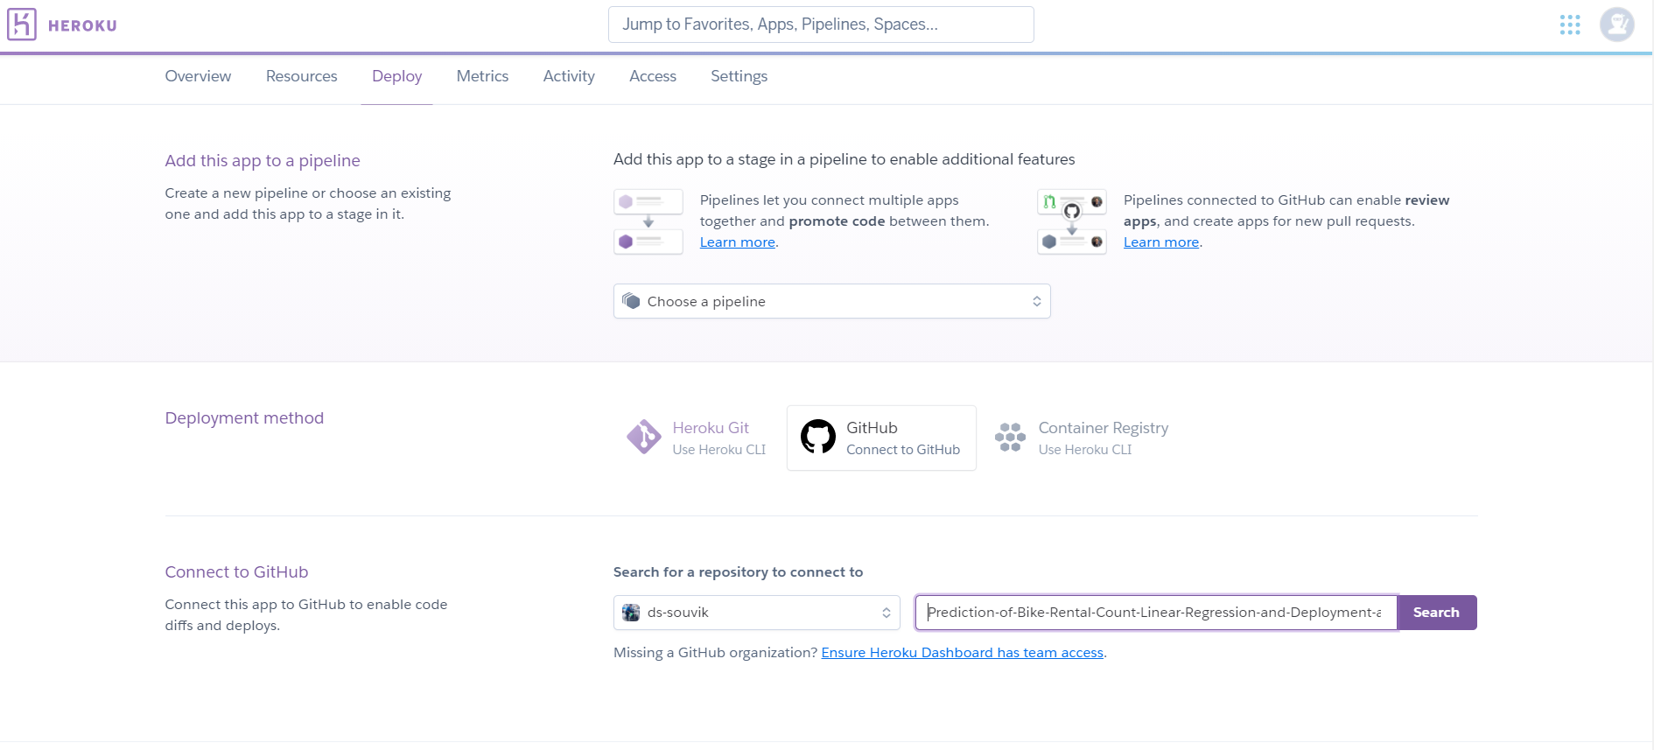

Clicked on Connect.

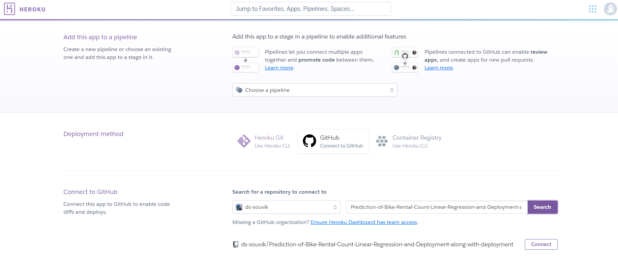

Here either of the type of deployments can be selected.

1. Enable Automatic Deploys
2. Deploy Branch.

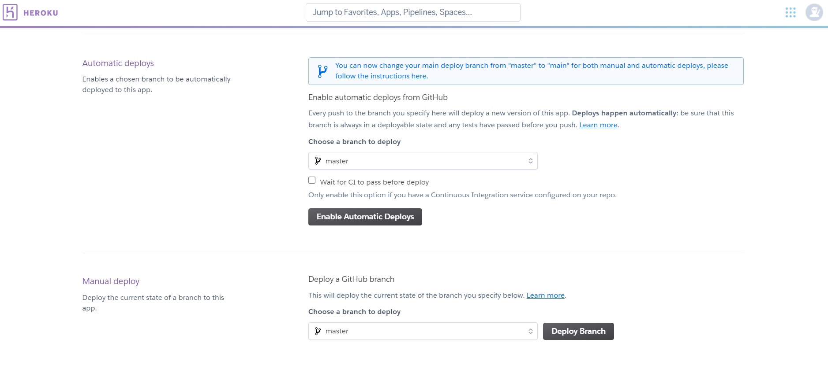

I chose Deploy Branch which is manual form of deployment. Whenever a change is deployed to GitHub, deployment has to be manual. For now, it’s saving me from deploying incorrect codes.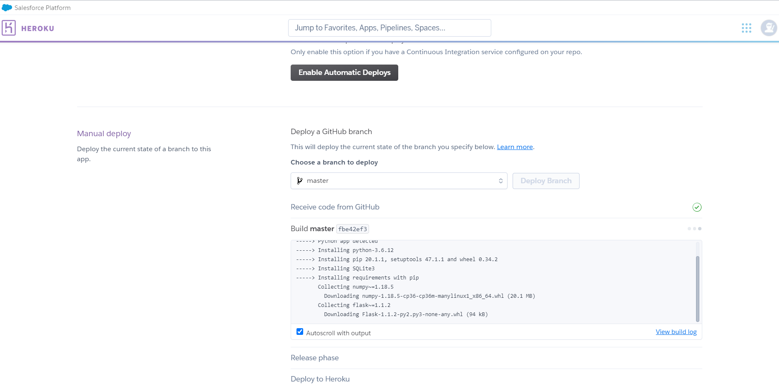

It will start installing all the libraries from requirements.txt

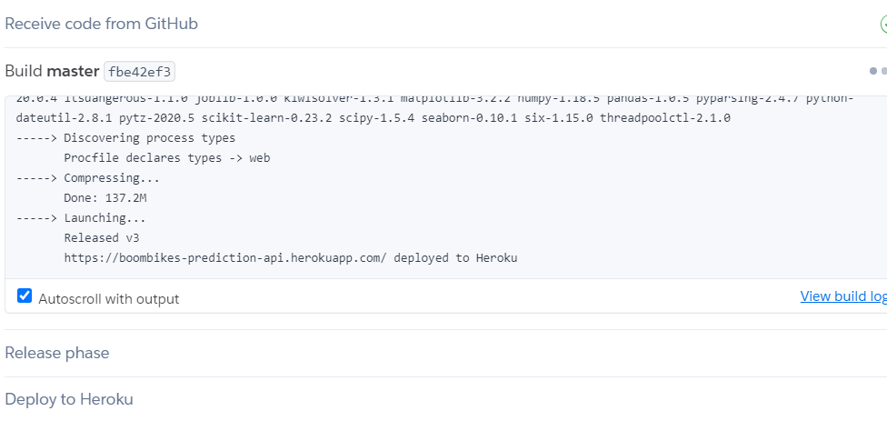

Now it’s just a matter of some time.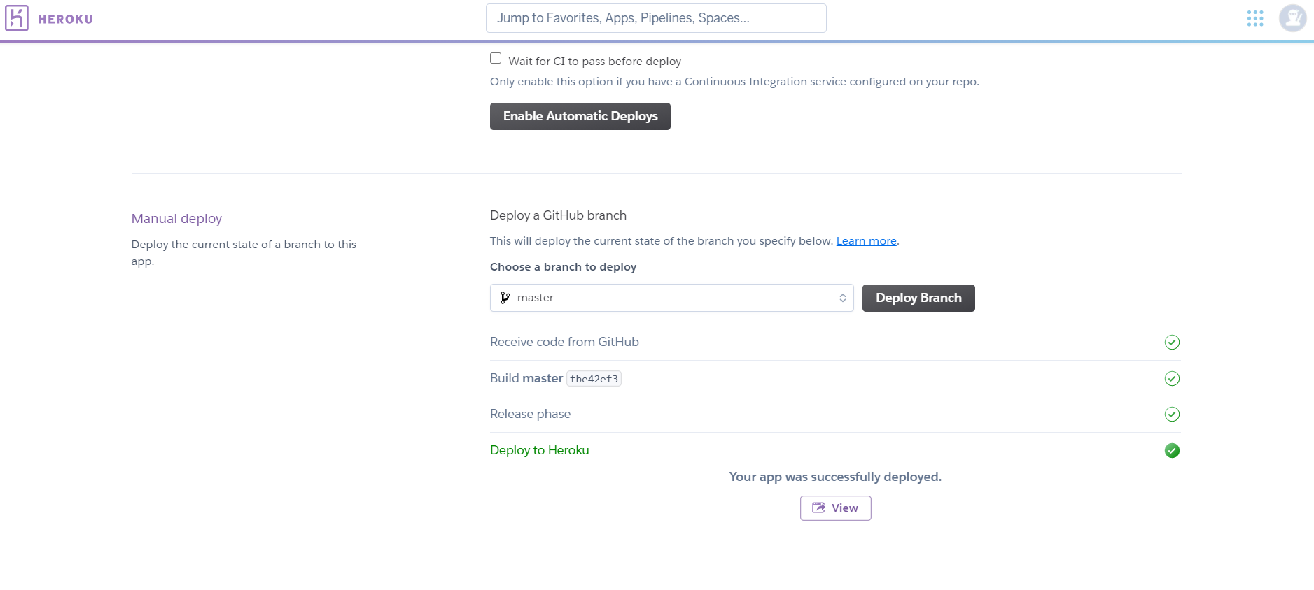

**VOILA! I HAVE JUST DEPLOYED MY FIRST MACHINE-LEARNING APPLICATION.**